**Assignment –7**

**Summarizing Data with Aggregate Functions.**

1. Write a query that counts all orders for October 3.

mysql> select count(*)

-> from orders

-> where odate = '1990-10-03';

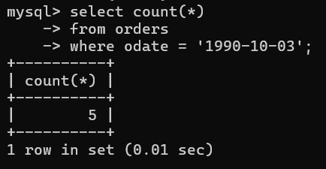

1. Write a query that counts the number of different non-NULL city values in the Customers table.

mysql> select count(distinct city)

-> from customers

-> where city is not null;

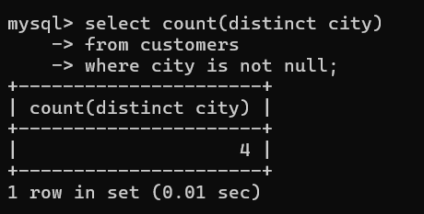

1. Write a query that selects each customer’s smallest order.

mysql> select cnum, min(amt)

-> from orders

-> group by cnum;

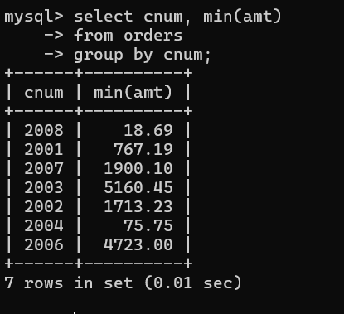

4)Write a query that selects the first customer, in alphabetical order,

whose name begins with G.

mysql> select *

-> from customers

-> where cname LIKE 'G%'

-> order by cname;

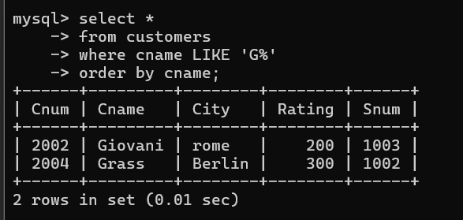

1. Write a query that selects the highest rating in each city.

mysql> select max(rating)

-> from customers;

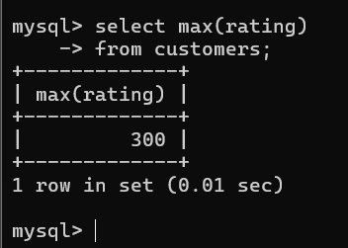

1. Write a query that counts the number of salespeople registering orders for each day. (If a salesperson has more than one order on a given day, he or she should be counted only once.).

mysql> select odate, count(distinct snum) As salespeopleCount

-> from orders

-> group by odate;

